Name: NGO TUNG CHUONG
ID: s225586848

YouTube: https://youtu.be/vdceG-AIRpc?si=gfgaYqG7ofi9BFpw
https://youtu.be/nQl_Zz43fMU?si=Oqf7GfvPtvH7abGG
GitHub: https://github.com/NoXxChapter/SIT122---Robotics-Studio.git

What is the unit of the ultrasonic sensor readings?
The unit of the ultrasonic sensor read was centimetre distance from the sensor eyes to the first surface it meets.

What was the stopping distance threshold you used in your code?
35 centimetres

When you look at your robot’s actual stopping distance from the obstacle: is it more, less, or the same from your distance threshold? Why?
Approximately stop distant perhaps. Usually, it always less than the distance threshold. Due to multiple reasons, inertial force, the design of robot, sudden appear of obstacle(s)…But most impact must be the delay time when the sonic travelled and bound back. Which create a notable delay we see.

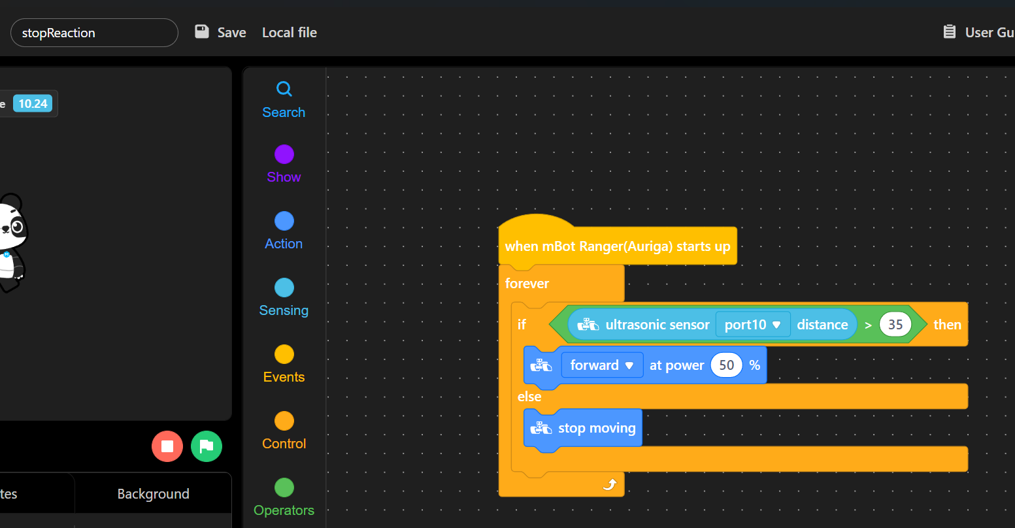
(Stop reaction)
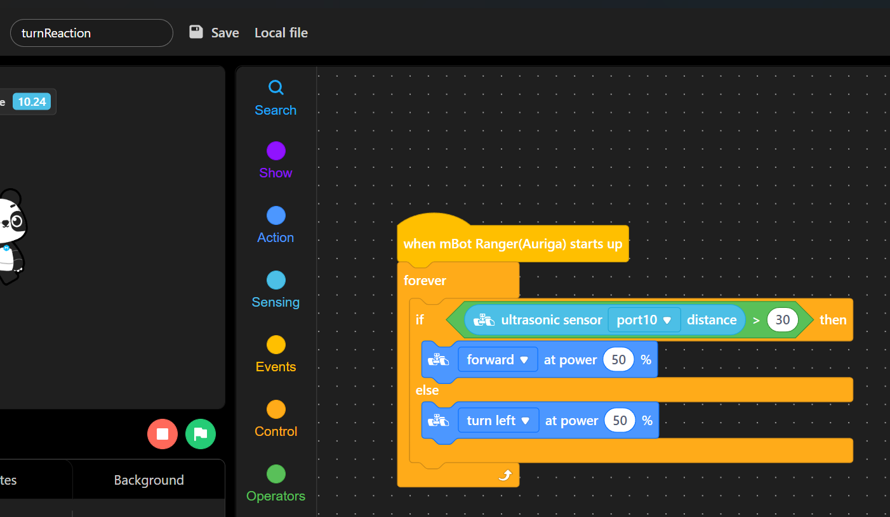
(Turn reaction)

